Noughts & Crosses

This is an activity to provide children with a hands-on demonstration of machine learning at an event like a Science Fair.

Children can try playing Noughts and Crosses against a computer. The computer will learn from the games that it plays, getting better throughout the Science Fair as it has more and more training.

*A version of this activity where students can work individually to train their own machine learning model and make their own project can be downloaded from* [*https://machinelearningforkids.co.uk/worksheets*](https://machinelearningforkids.co.uk/worksheets)

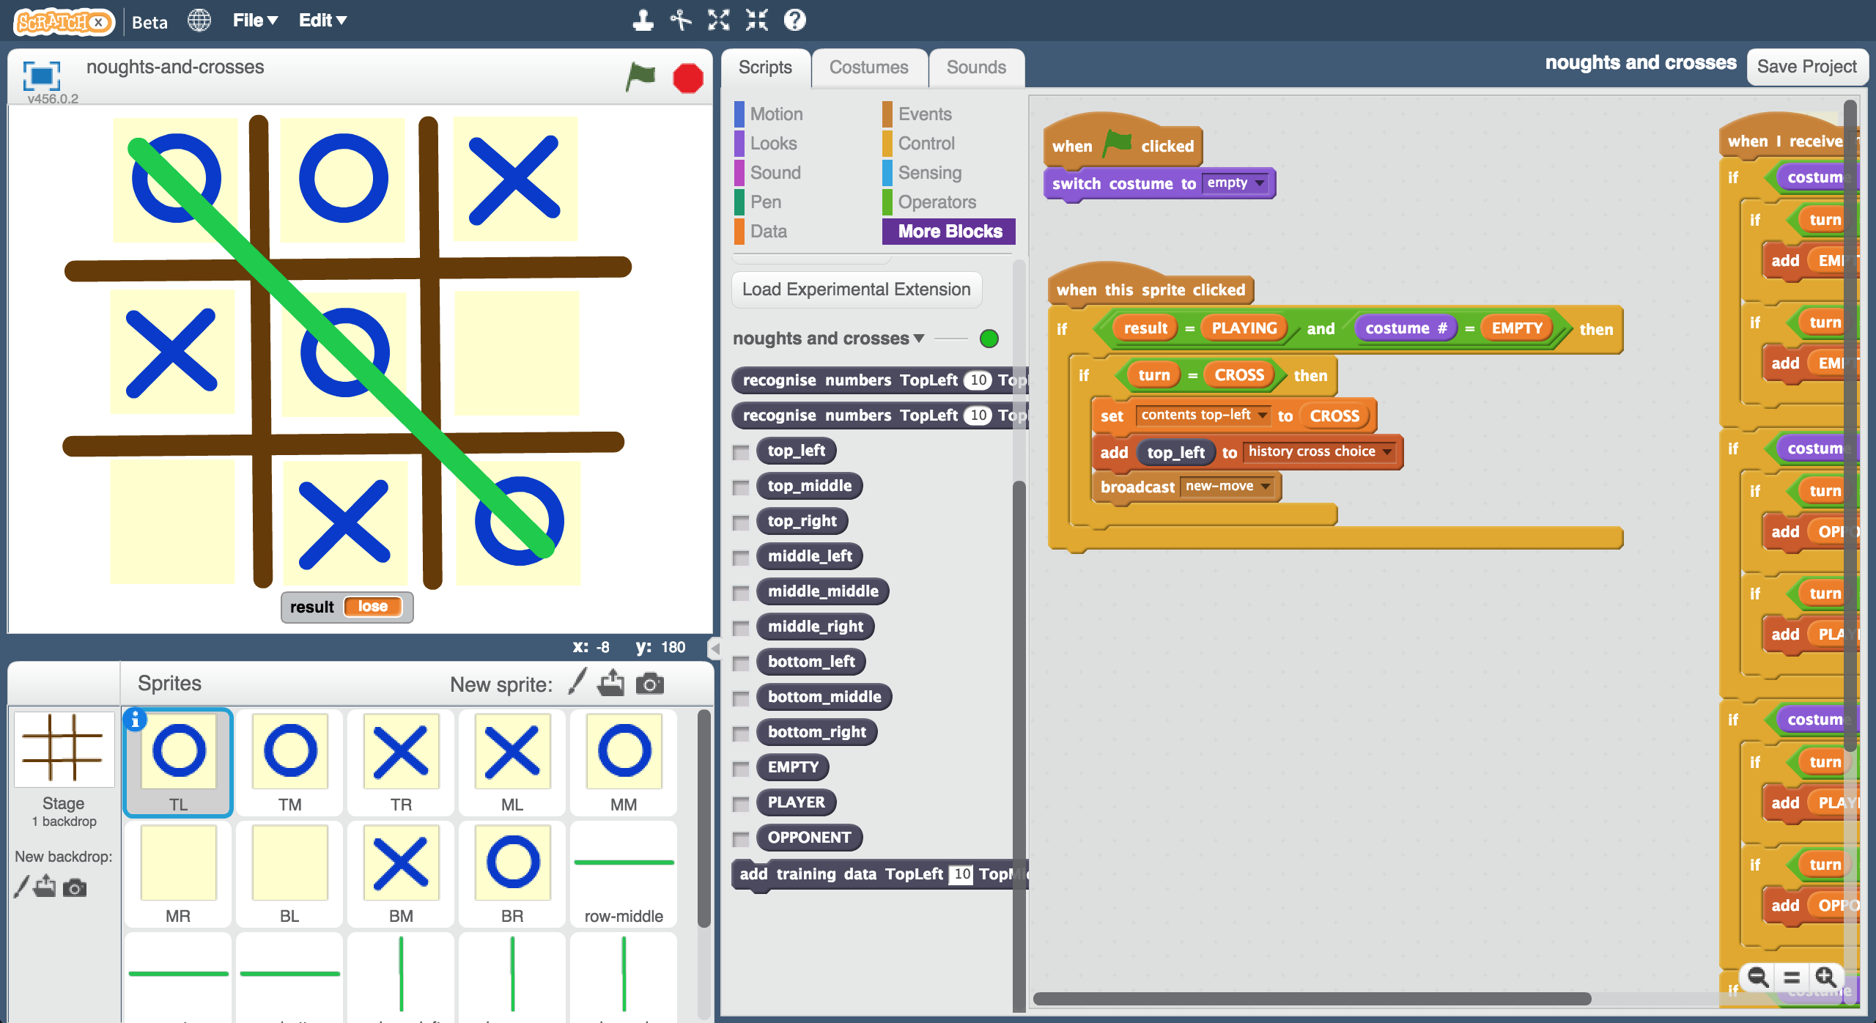

This project worksheet is licensed under a Creative Commons Attribution Non-Commercial Share-Alike License

http://creativecommons.org/licenses/by-nc-sa/4.0/

This version of the “Noughts & Crosses” activity is intended for use at events like Science Fairs, where there will be a very large number of children over an extended period, but where individual children will only get a minute or two to try an activity.

Each child who tries will play noughts and crosses against the computer. In doing so, they each contribute a small amount of training to a shared machine learning model. As the event continues, the computer will learn from games that the children play against it, and get better and better at playing the game.

*Before the event*

Scratch demo preparation

Project preparation

*During the event*

Repeat a few times

Repeat a few times

*At the start of the event*

Computer makes moves using the machine learning model

Moves made by the winner added to training data

Young person plays Noughts and Crosses

Event leader creates a new machine learning model using training data of all moves made so far

Moves made by the winner added to training data

Computer makes moves at random

Young person plays Noughts and Crosses

Set up device for event leader

Set up computer(s) for young people

**Event leader instructions : Project preparation**

**Objective:** Create a group project & prepare it for use at your event

1. Go to <https://machinelearningforkids.co.uk/> in a web browser
2. Login using your teacher username/password
3. Click on “**Projects**” in the top menu bar
4. Click on the “**+ Add a new project**” button
5. Create a project called “noughts and crosses”, set to recognise “**numbers**” and make sure you tick the “**Whole-class project**” checkbox  
   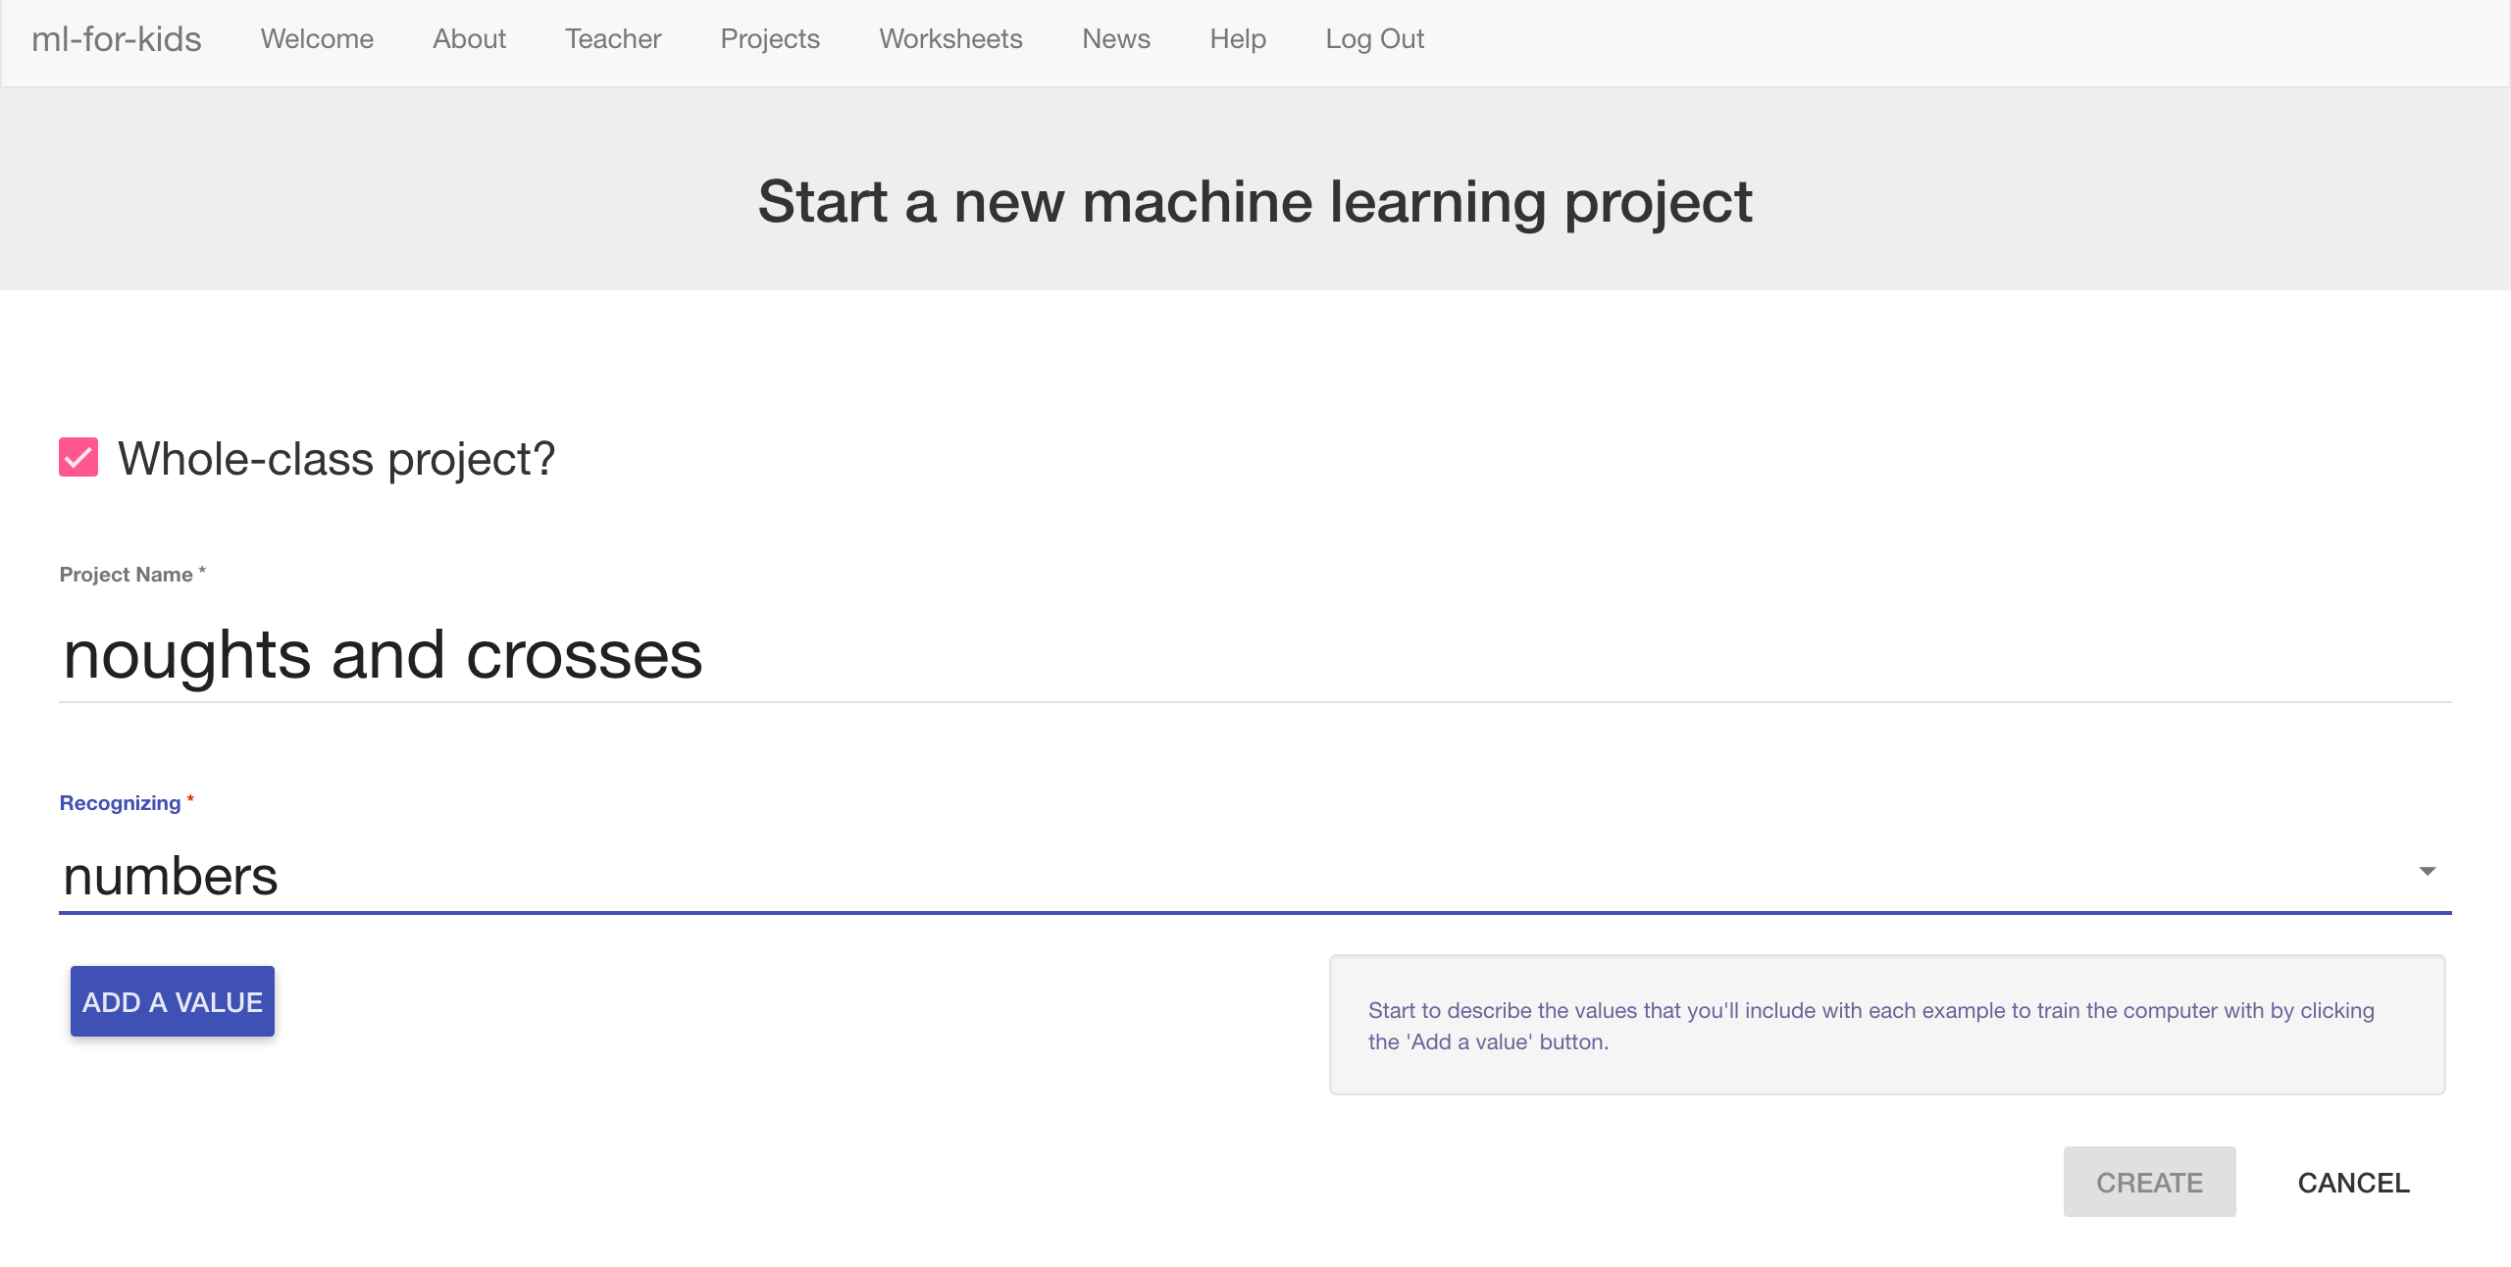
6. Click “**Add a value**”. Name a value “TopLeft”, and make it “multiple-choice”  
   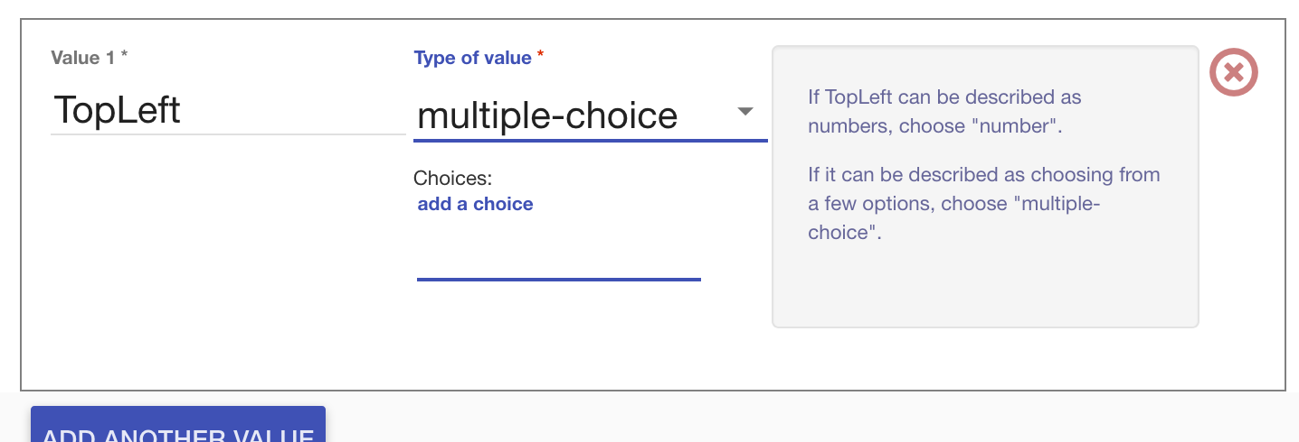
7. Type “EMPTY” into the “**add a choice**” box and press Enter  
   Type “PLAYER” into the “**add a choice**” box and press Enter  
   Type “OPPONENT” into the “**add a choice**” box and press Enter  
     
   *These are the possible contents for the top-left box in the noughts and crosses board. It can be empty, or it can have the player’s own shape (e.g. cross) in it, or it can have the opponent’s shape in it (e.g. nought).*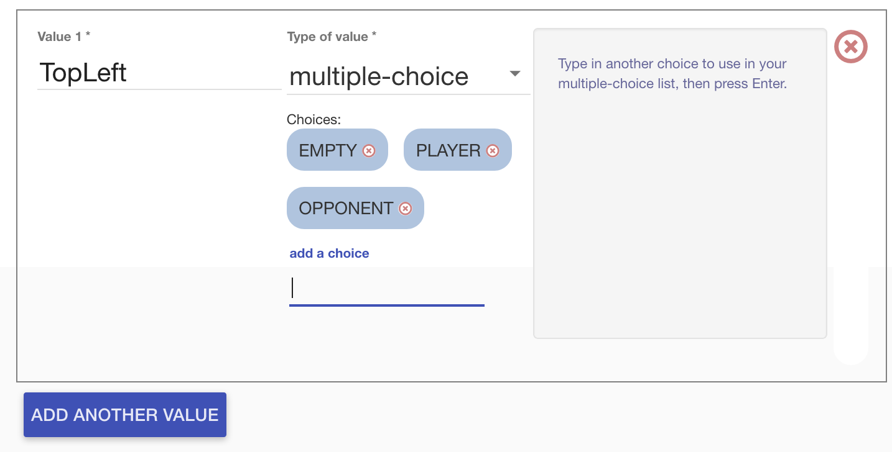
8. Click “**Add another value**” again and repeat to add values for the other eight positions on the board  
     
   *Each example is the state of the board before a move that led to a win.   
   TopMiddle, TopRight, MiddleLeft, MiddleMiddle, MiddleRight, BottomLeft, BottomMiddle, BottomRight  
     
   It’s very important that you spell “EMPTY”, “PLAYER” and “OPPONENT” in the same way for all nine positions.*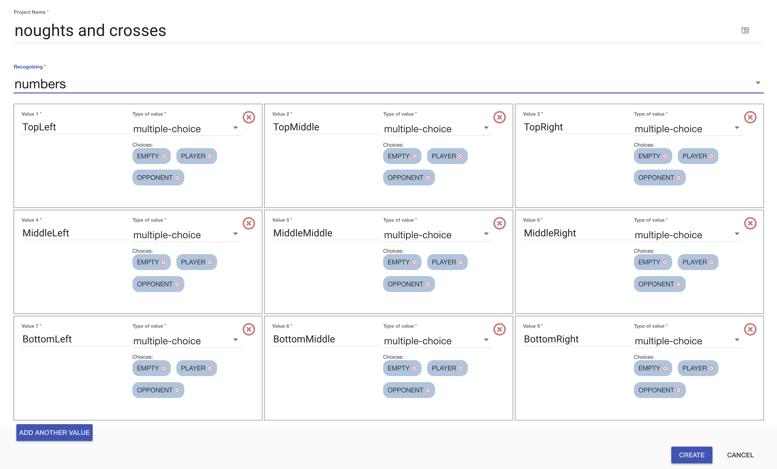
9. Click “**Create**”.
10. You should see “**noughts and crosses**” show up in the list of your projects. Click on it.   
    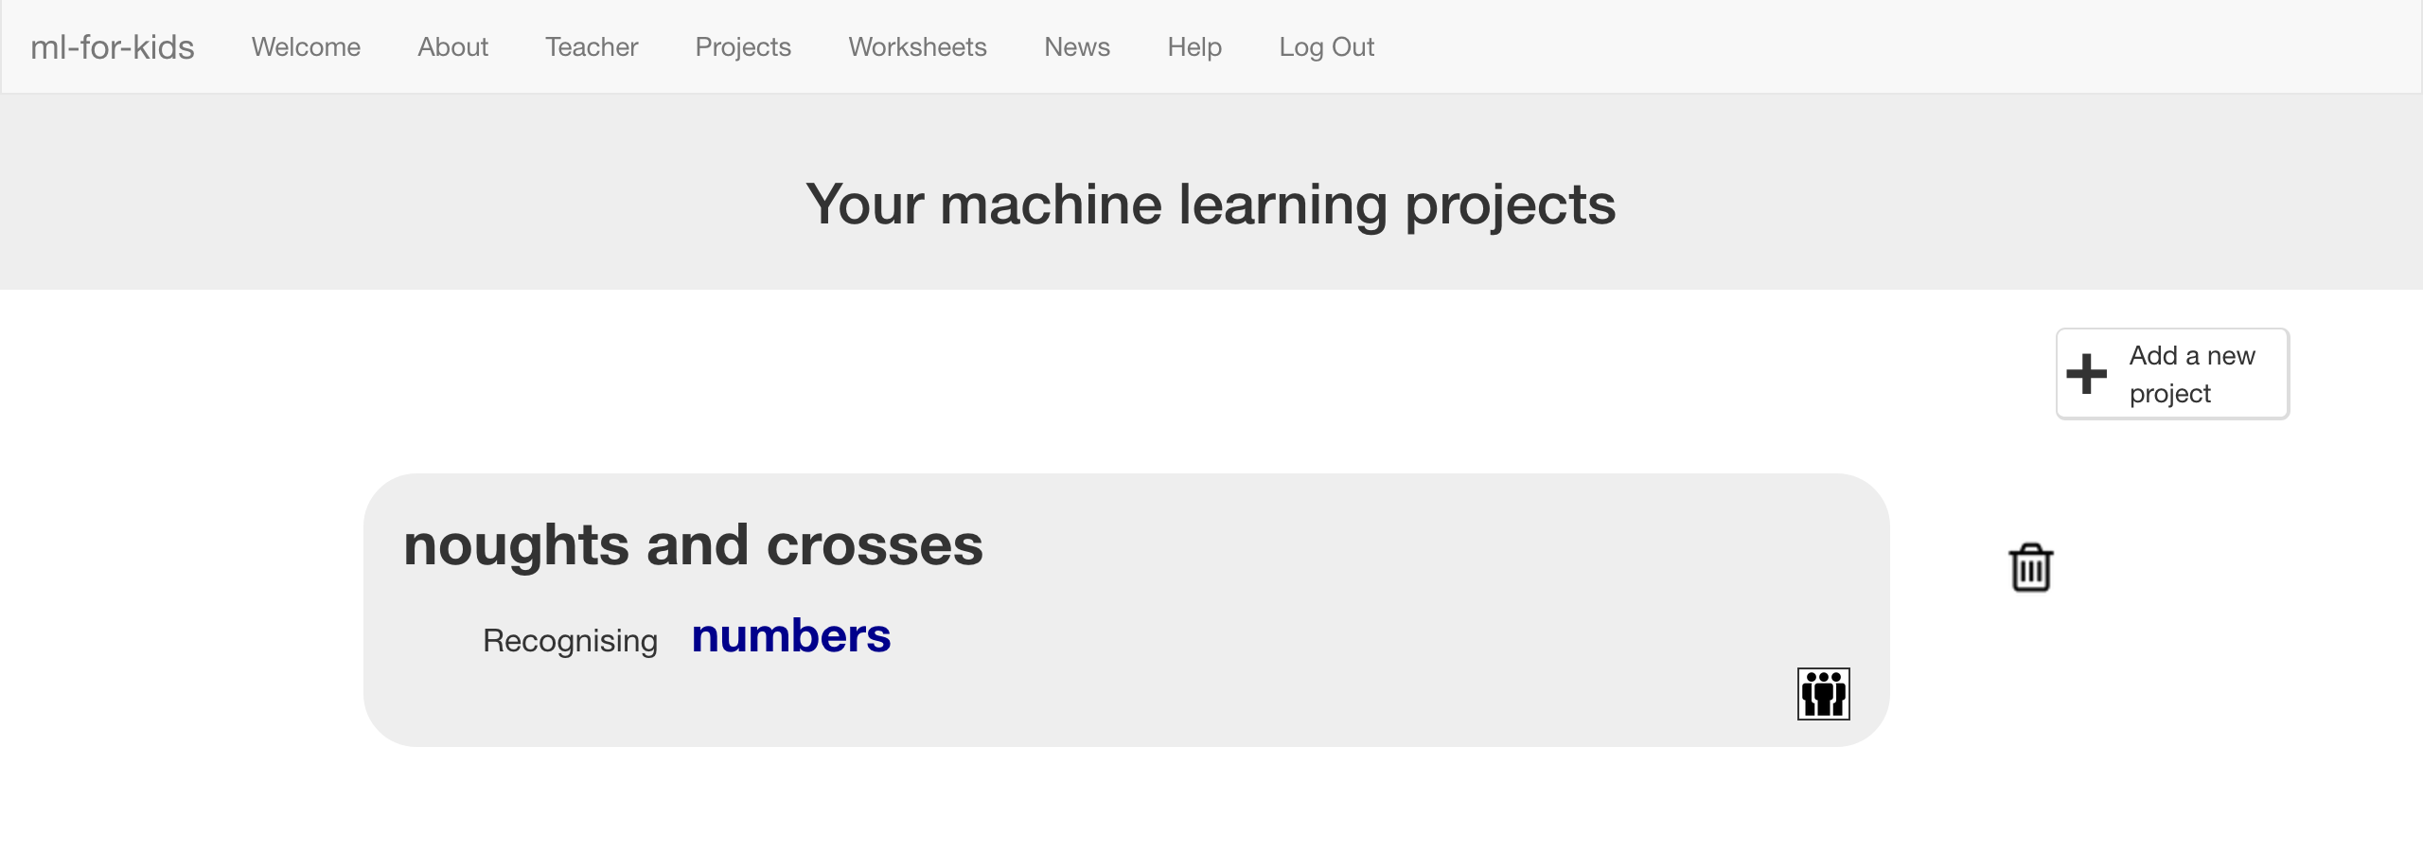
11. Click the “**Train**” button
12. Click “**+ Add new label**” and create a label called “top left”  
    *Examples of making a move in the top-left box (in games that eventually ends in a win) will go in this bucket.*  
    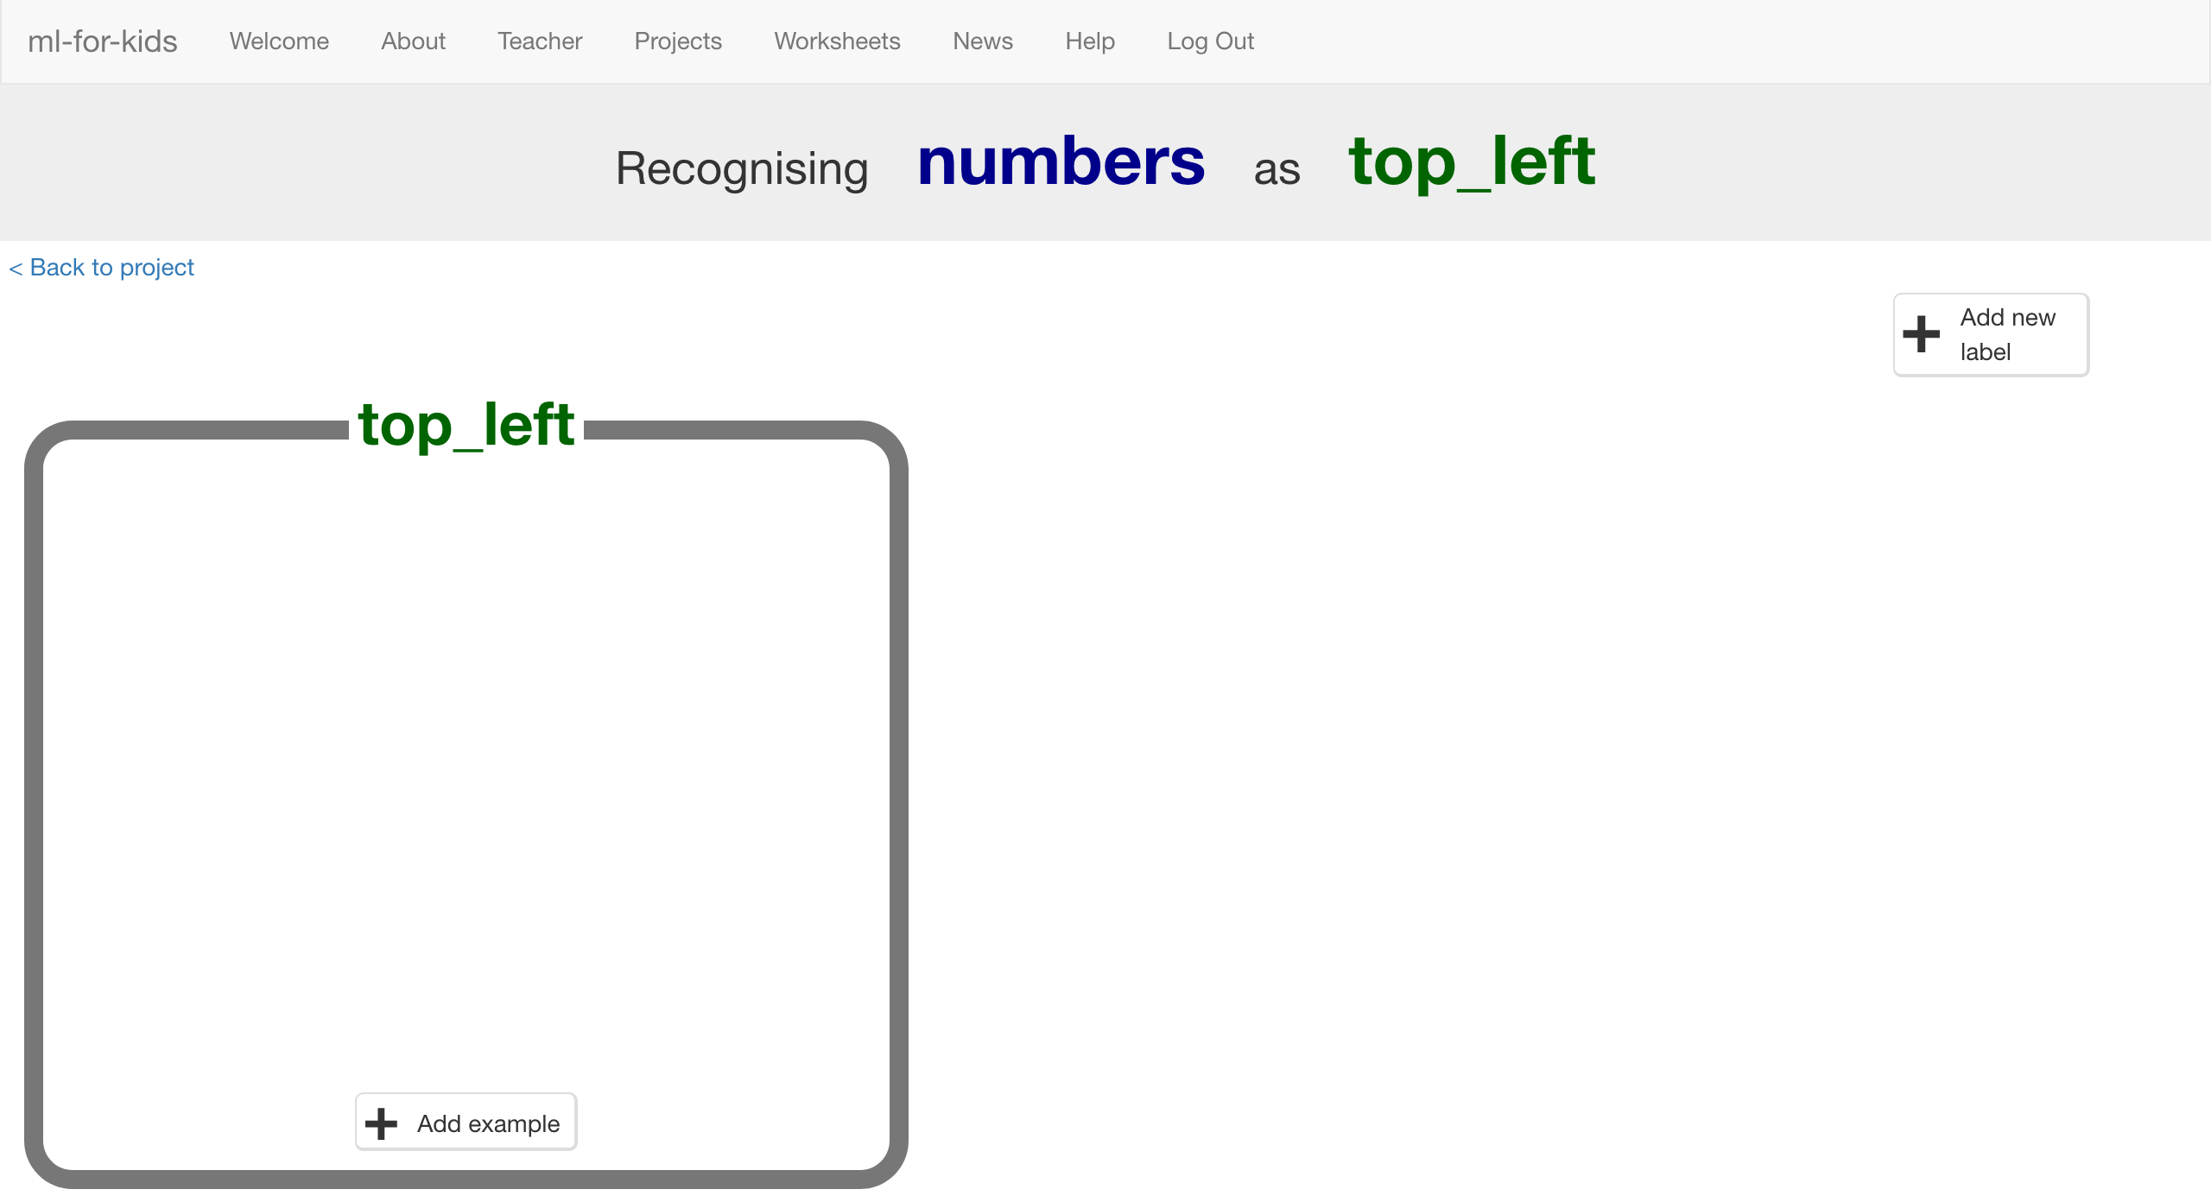
13. Click “+ Add new label” again, and create labels for the other eight spaces on a noughts and crosses board.  
    *“top middle”, “top right”, “middle left”, “middle middle”, “middle right”, “bottom left”, “bottom middle”, “bottom right”*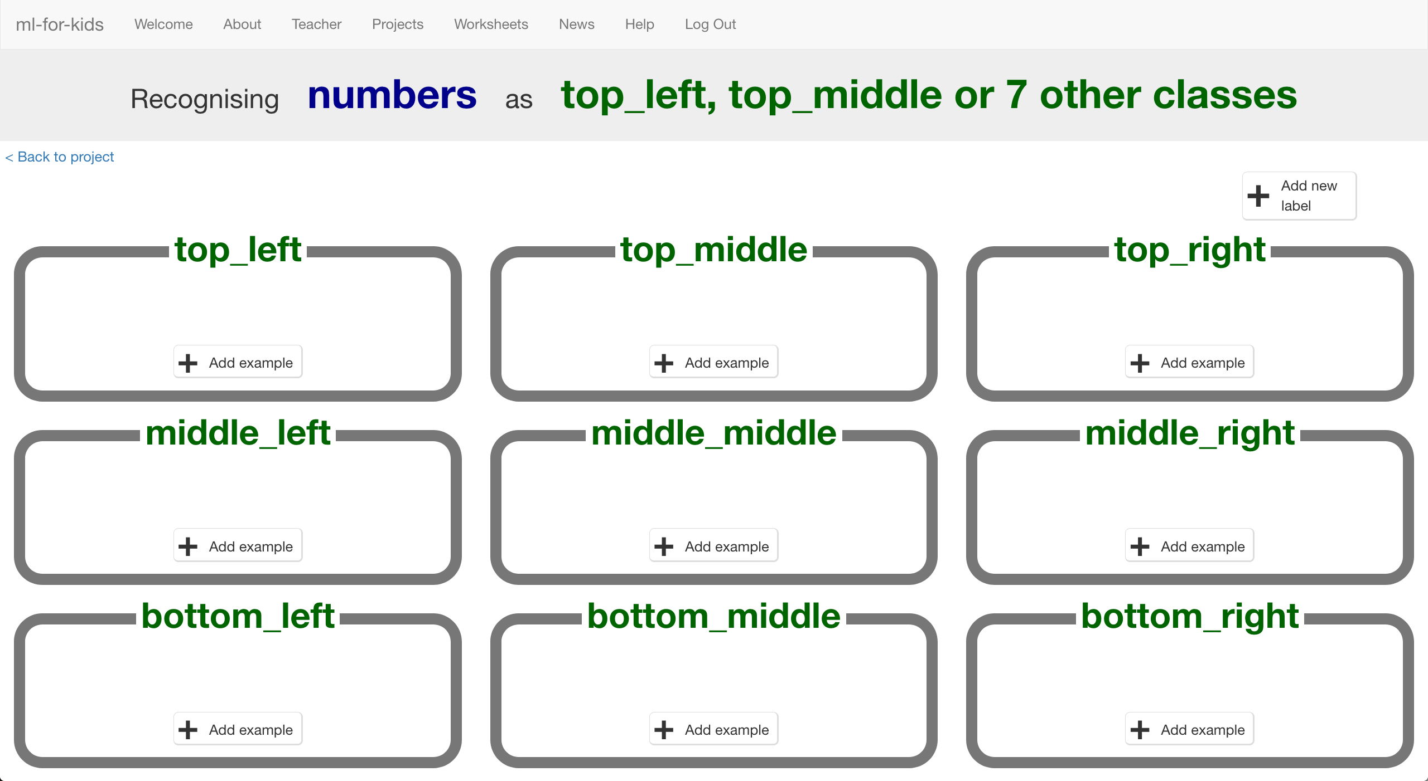

**Event leader instructions : Scratch demo preparation**

**Objective:** Create the Scratch project that children will use

1. Download this template project file  
   <https://github.com/dalelane/ml-for-kids/raw/master/worksheets/noughts-and-crosses.sbx>
2. Go to <https://machinelearningforkids.co.uk/> in a web browser
3. Login using your teacher username/password
4. Click on “**Projects**” in the top menu bar
5. Click on “**noughts and crosses**” in the list of projects  
   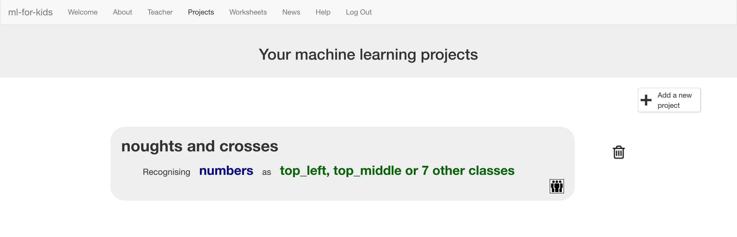
6. Click the “**Scratch**” button
7. Click the “**Open in Scratch**” button  
   *There will be a message saying that you haven’t trained a machine learning model yet. Ignore it – click the “****straight into Scratch****” button.*  
   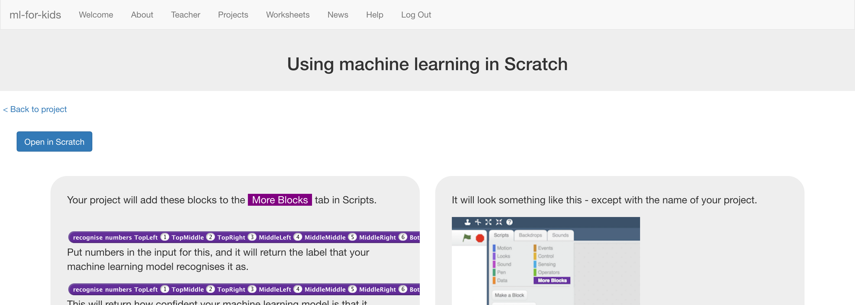
8. Scratch will be opened, with some custom blocks from the machine learning project that you have setup  
   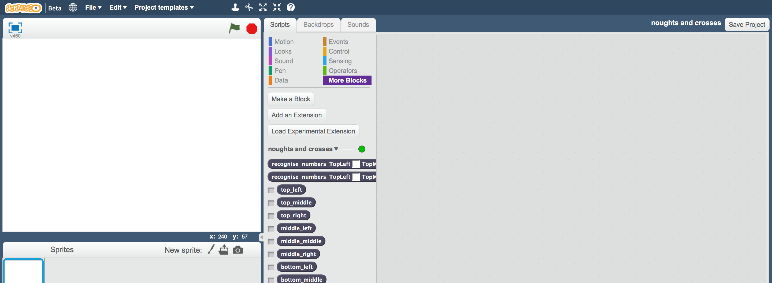
9. Open the template project file downloaded earlier  
   *Click “****File****” -> “****Load project****”  
   Click “****OK****” when prompted to replace the contents of the current project*  
   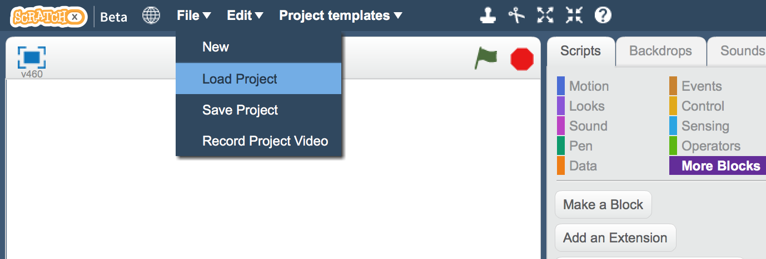
10. Click on the “**Stage**”  
    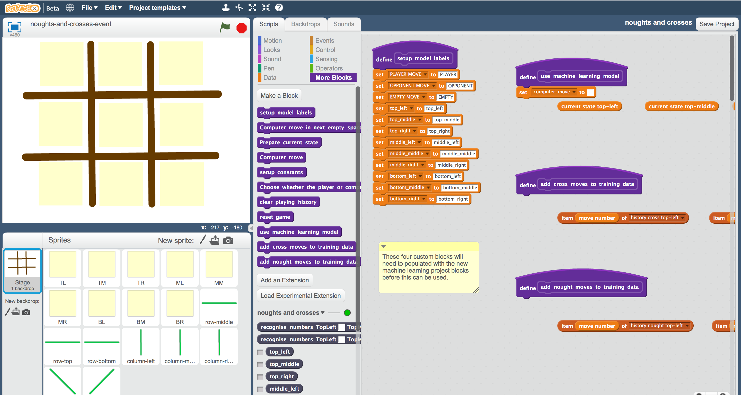
11. Update the “**setup model labels**” script  
    *This technically isn’t necessary, but it will mean that things will still work even if you’ve spelled anything slightly differently when setting up the project.   
    Update it to look like this, by copying in the dark-blue blocks from your ML project:  
    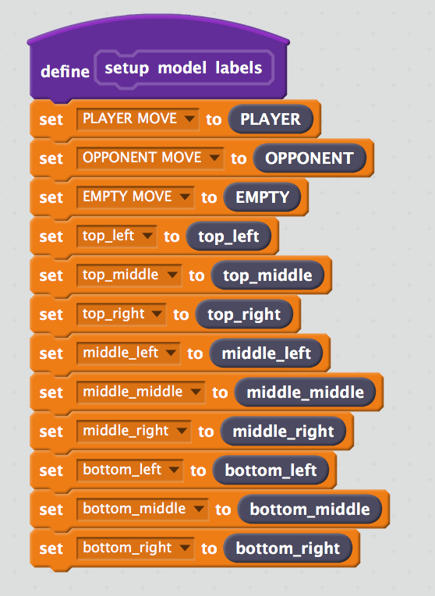*
12. Update the “**use machine learning model**” script  
    *Start by copying in the “****recognise numbers … (label)****” block from your ML project.  
    Make sure you choose the (label) one, and not the (confidence) one.   
    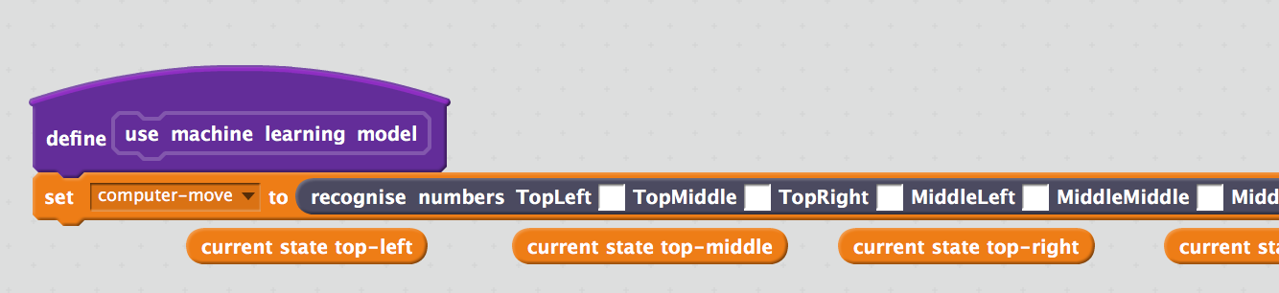  
      
    Next, copy in the orange “current state…” blocks into the spaces in your   
    “recognise numbers” block.   
      
    They are lined up for you underneath, already in the right order.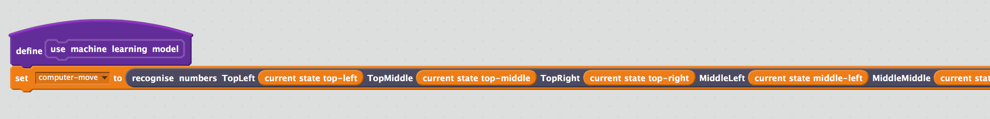 Check that you match up the names correctly.   
      
    e.g. the arrows above show that the “current state top-middle” block goes in the hole next to the “TopMiddle” label.   
      
    Do this for all nine blocks, not just the few that are visible in the screenshot. This means needing to scroll to the right a bit!*
13. Update the “**add cross moves to training data**” block  
    *Start by copying in the “****add training data …****” block from your ML project.  
    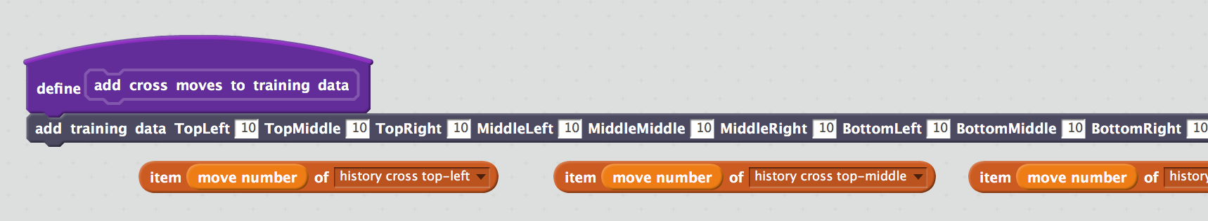*  
    *Next, copy in the orange “item…” blocks into the spaces in your   
    “add training data” block.   
      
    As before, they are prepared for you underneath, already in the right order.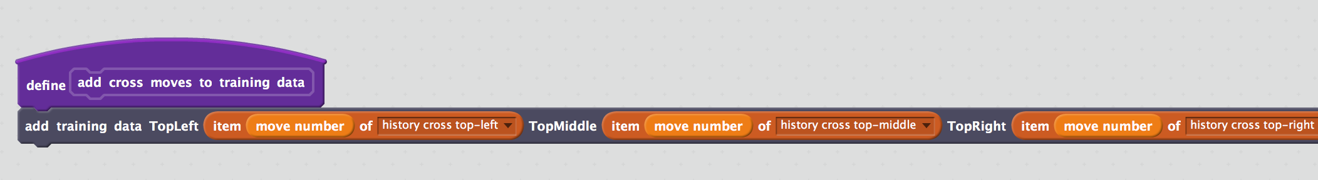 As before, check that you match up the names correctly.   
      
    e.g. the arrows above show that the “item … top-middle” block goes in the hole next to the “TopMiddle” label.   
      
    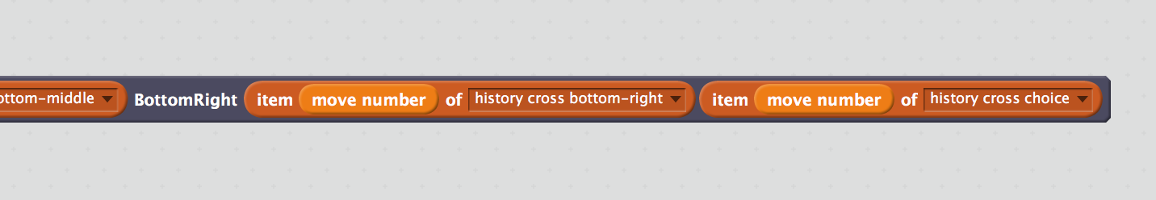  
      
    The last block is the choice that the player makes.*
14. Update the “**add nought moves to training data**” block  
    *Start by copying in the “****add training data …****” block from your ML project.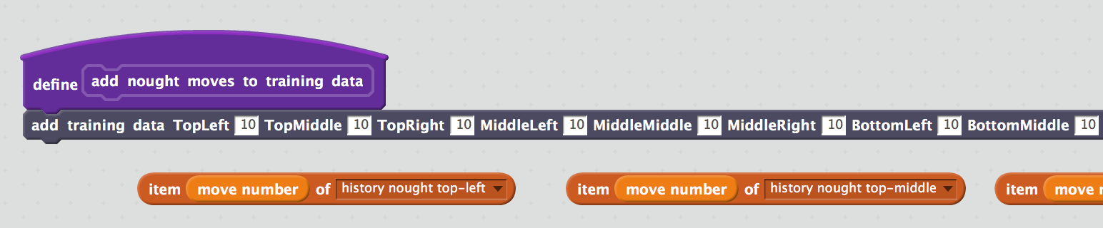 Next, copy in the orange “item…” blocks into the spaces in your   
    “add training data” block.   
      
    As before, they are prepared for you underneath, already in the right order.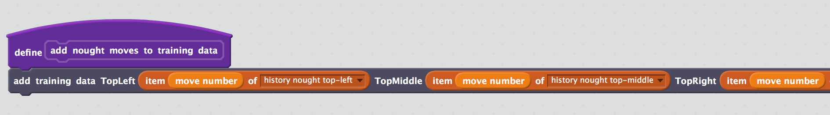 As before, check that you match up the names correctly.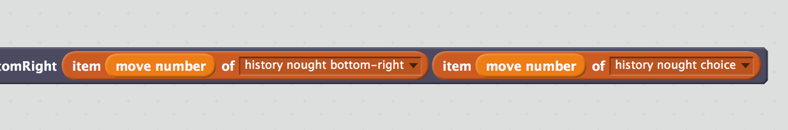 As before, the last block is the choice that the player makes.*
15. The project is ready to use. Save the project to a file to keep it safe  
    *Click on “****File****” -> “****Save project****”*  
    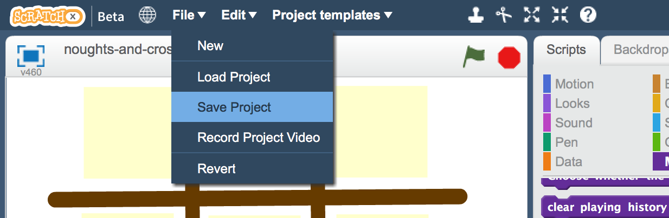

**Event leader instructions : At the start of the event**

For the event, you will need:

* **Computer(s) for young people visiting the event to use**  
  This can be a computer or a laptop – it needs to be able to run Scratch  
  There isn’t a limit on how many of these you have – if you’re going to have lots of young people at the event, you can have lots of laptops!
* **Device for event leader**This can be a computer, or it could be a tablet or smartphone.   
  It doesn’t need to run Scratch. It will be used to monitor progress and refresh the machine learning model throughout the event.

**Objective:** Set up the computer(s) for use by young people

1. Go to <https://machinelearningforkids.co.uk/> in a web browser
2. Login using your **student** username/password  
   **Don’t** use your teacher username/password – the teacher logon can perform destructive actions, like deleting large amounts of training data or even the entire project.   
   The student username/password is safer as it can only add to the training data and use the machine learning model.
3. Click on “**Projects**” in the top menu bar
4. Click on “**noughts and crosses**” in the list of projects  
   
5. Click the “**Scratch**” button
6. Click the “**Open in Scratch**” button  
   
7. Open the project file created earlier in the **Scratch demo preparation** step  
   *Click “****File****” -> “****Load project****”  
   Click “****OK****” when prompted to replace the contents of the current project*  
   

*During the event*

**Instructions:** Activity by young people during the event

Play Nought and Crosses in Scratch

**Tip:** Playing in full-screen mode is safer as it will prevent students accidentally moving

the game board parts during the game.

The computer will use a machine learning model to decide on the moves that it will take. That model is trained using the games previously played by young people.

Click on the Green Flag to start a new game.

**Objective:** Set up the device for use by the event leader

1. Go to <https://machinelearningforkids.co.uk/> in a web browser
2. Login using your teacher username/password
3. Click on “**Projects**” in the top menu bar
4. Click on “**noughts and crosses**” in the list of projects  
   
5. Click on the “**Learn & Test**” button
6. Bookmark this page – you’ll use it throughout the event  
   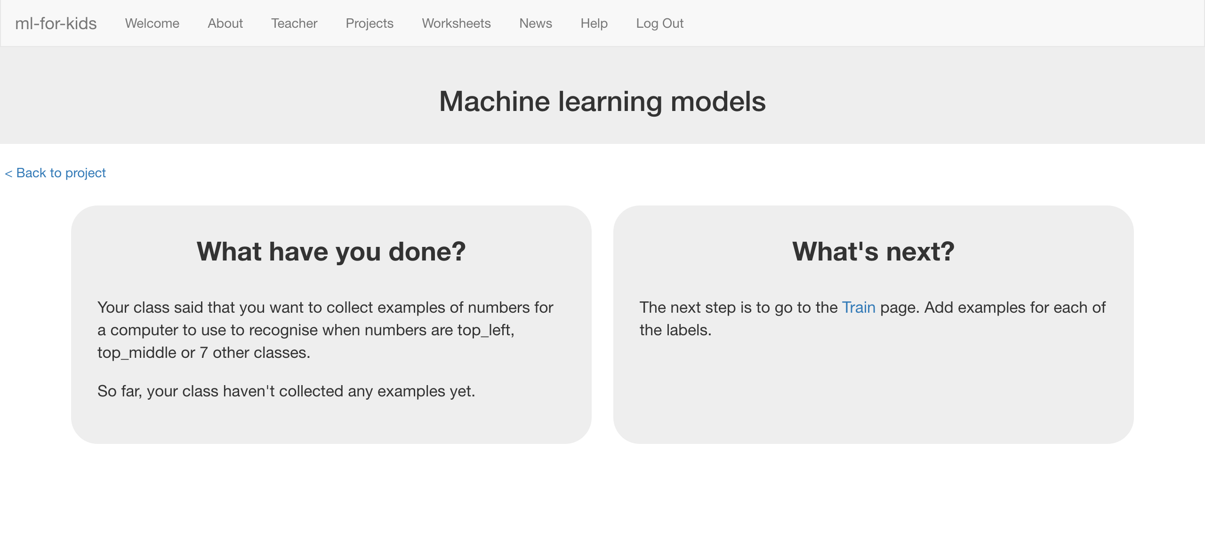

**Instructions:** Event leader responsibilities during the event

The “Learn & Test” page will let you monitor the progress throughout the event.

Refresh the page periodically to see how things are going.

*During the event*

After every 5 – 10 games or so, click the “**Train new machine learning model**” button to train a new machine learning model. The new training examples that children are collecting **only have an impact after they are used to train a new model**.

**Before any children have played any games…**

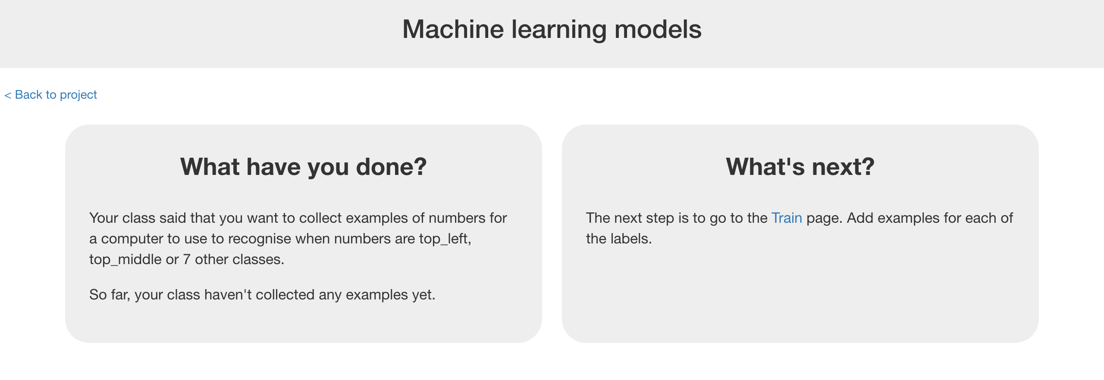

**After the first few games…**

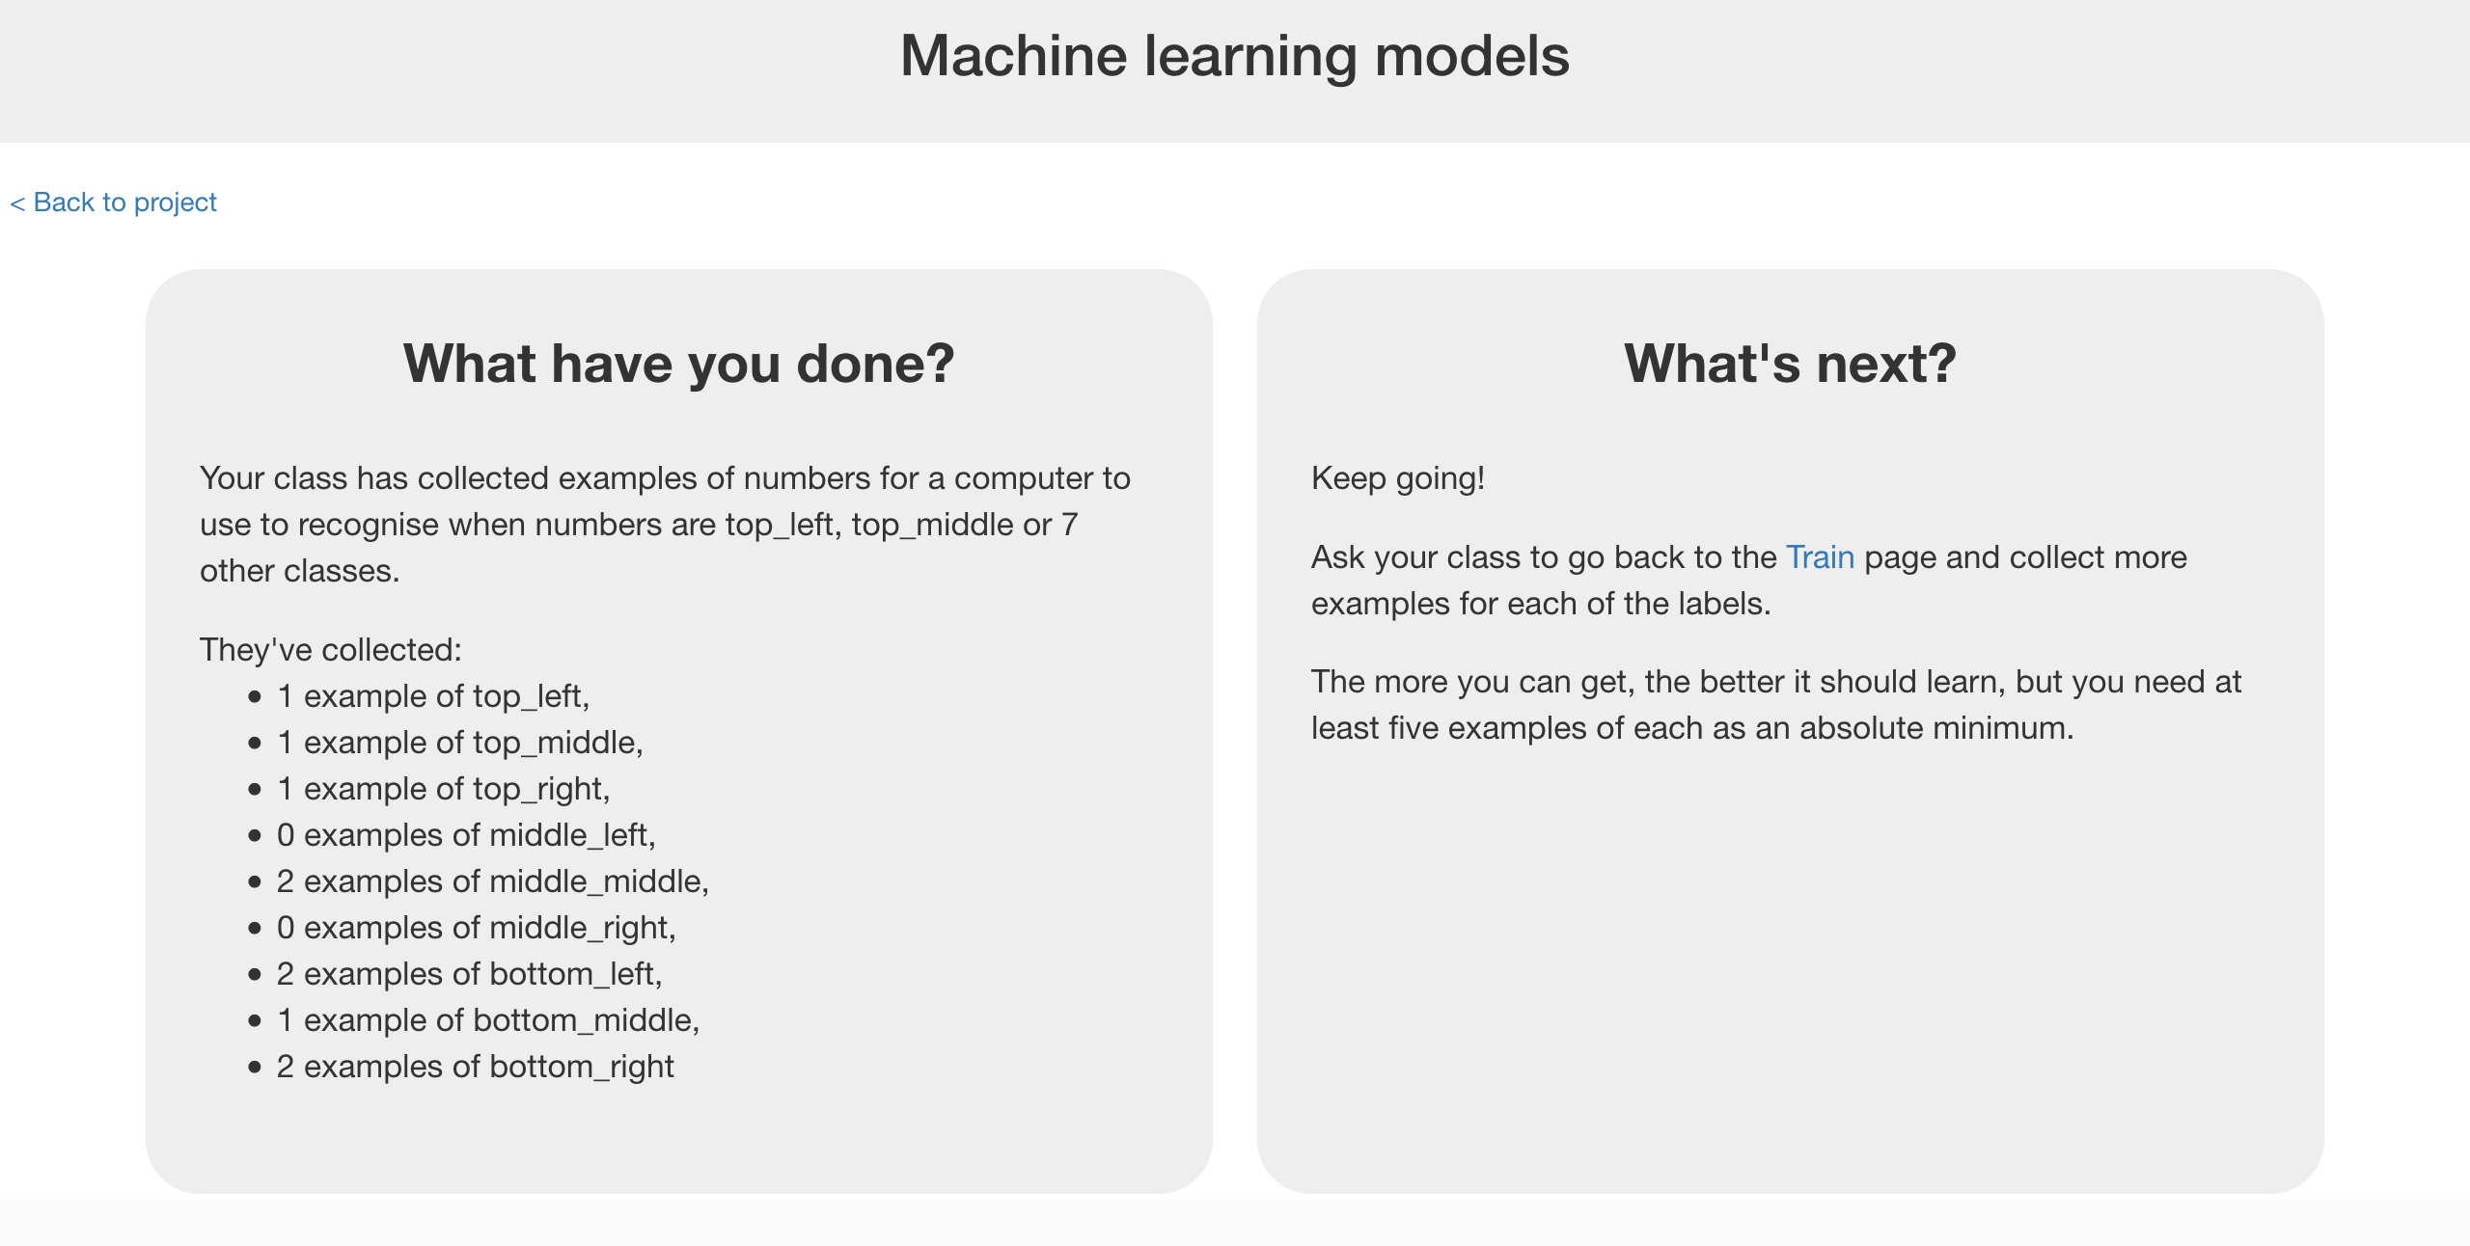

**After enough games to be able to train a machine learning model…**  
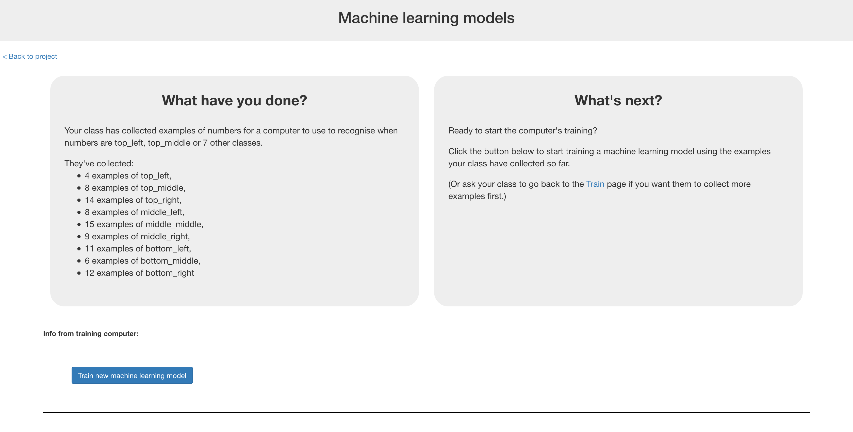

**After there is a working machine learning model, but enough training data to train a better one…**



**Event leader instructions : After the event**

**Objective:** Clear-up after the event is over

1. Go to <https://machinelearningforkids.co.uk/> in a web browser
2. Login using your teacher username/password
3. Click on “**Projects**” in the top menu bar
4. Click on the trash can Delete button next to “noughts and crosses”  
   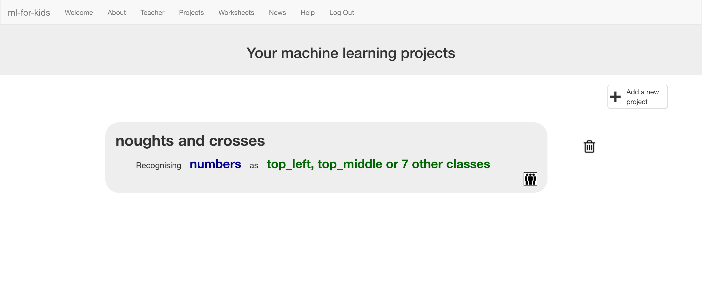

Representing noughts and crosses in Scratch

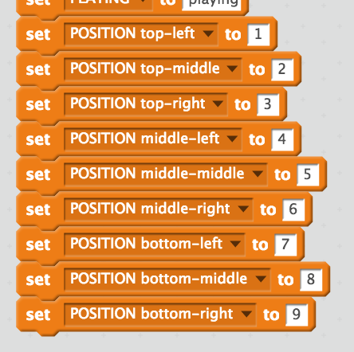

The positions of spaces on the noughts and crosses board are numbered from 1 to 9.

Data constants are used to make it easier to refer to them in scripts.

3

2

1

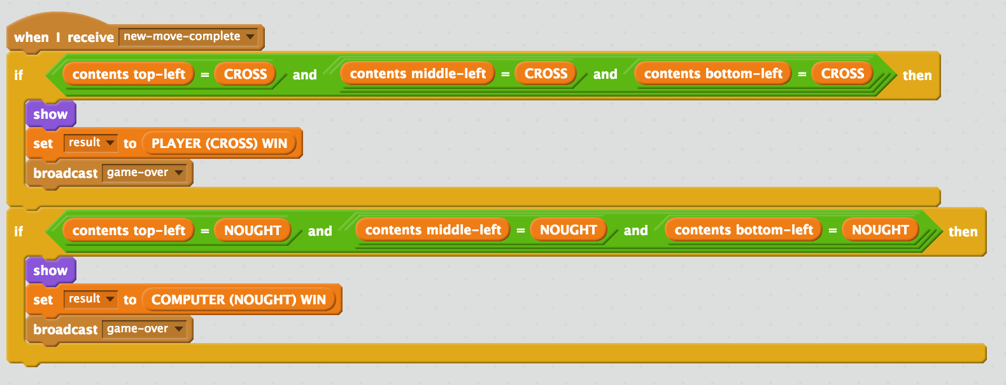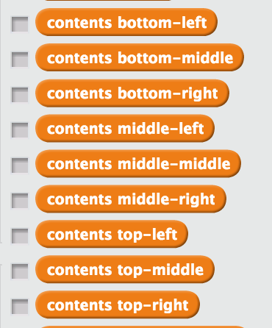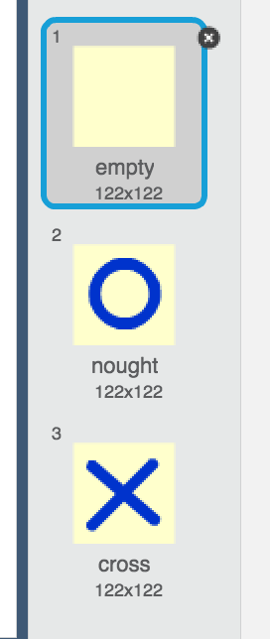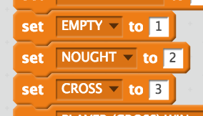

Variables are used to store the current state of the game.

For example, at this point:

contents top-left = 2

contents middle-middle = 3

contents bottom-right = 1

Each of the green row and column sprites check to see if someone has won.

This happens after every move.

X

O

Empty = 1

O = 2

X = 3

An empty space is shown in costume 1.

A nought is shown in costume 2.

A cross is shown in costume 3.

Data constants are used to make it easier to refer to these in scripts.

9

8

7

6

5

4

**What is happening?**

You’re training a computer to play noughts and crosses. You do this by showing it examples of how you play the game.

Imagine the board looks like this and

it is O’s turn.

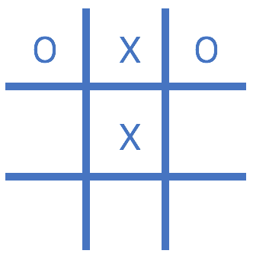

Imagine you decide to put your O in

the bottom middle space.

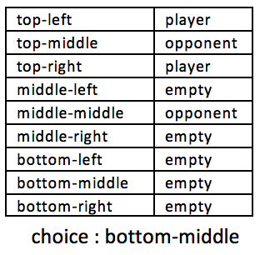

Imagine the board looks like this and

it is X’s turn.

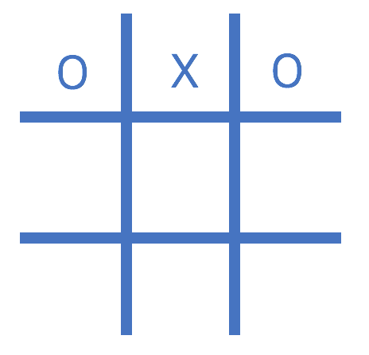

Imagine you decide to put your X in

the centre space.

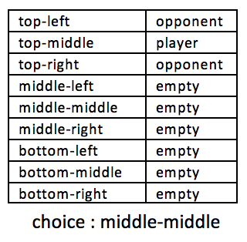

You’re collecting examples of moves from the player that wins the game.

If you (X) win, your moves are used as examples to train the computer.

If the computer (O) wins, the computer’s moves are used to train with.

These **examples of moves that lead to winning** will teach the computer how to play to win!

**Did you know?**

People have been learning about machine learning by training a computer to play noughts and crosses for decades!

One famous example was **Donald Michie** – a British artificial intelligence researcher. During World War II, Michie worked at Bletchley Park as a code breaker.

In 1960, he developed “**MENACE**” – the Machine Educable Noughts And Crosses Engine. This was one of the first programs able to learn how to play noughts and crosses perfectly.

As he didn’t have a computer he could use, Michie built MENACE using 304 matchboxes and coloured glass beads.

Each matchbox represented a possible state of the board – like the examples that you’ve been collecting in your training data.

He put beads in the matchboxes to show how often a choice led to a win – adding and removing these coloured beads was how his system represented the training data used to train the system.

